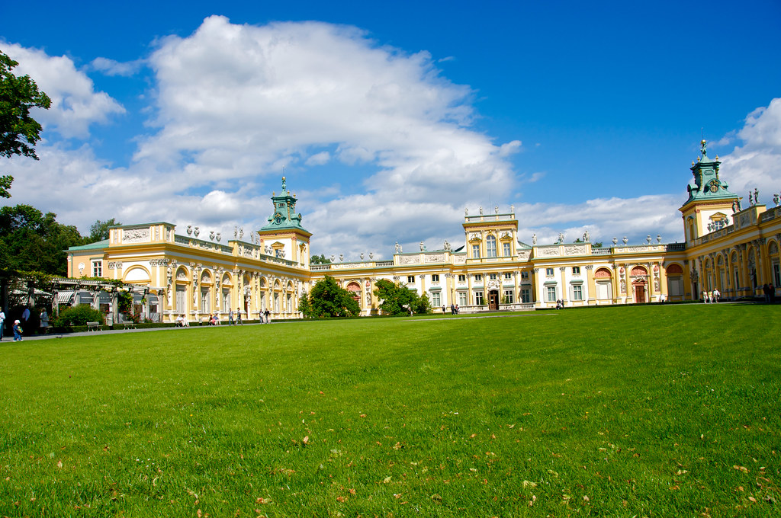

# Wilanów Palace

**Wilanów Palace** ([Polish](https://en.wikipedia.org/wiki/Polish_language): *Pałac w Wilanowie*, Polish pronunciation: [[ˈpawad͡z v vilaˈnɔvjɛ]](https://en.wikipedia.org/wiki/Help:IPA/Polish)) is a former [royal palace](https://en.wikipedia.org/wiki/Royal_palace) located in the [Wilanów](https://en.wikipedia.org/wiki/Wilan%C3%B3w" \o "Wilanów) district of [Warsaw](https://en.wikipedia.org/wiki/Warsaw), Poland. It was built between 1677–1696 for king of Poland [John III Sobieski](https://en.wikipedia.org/wiki/John_III_Sobieski) according to a design by architect Augustyn Wincenty Locci. Wilanów Palace survived [Poland's partitions](https://en.wikipedia.org/wiki/Partitions_of_Poland) and both World Wars, and so serves as one of the most remarkable examples of [Baroque architecture](https://en.wikipedia.org/wiki/Baroque_architecture) in the country.

It is one of Poland's most important monuments. The [palace's museum](https://en.wikipedia.org/wiki/Palace_Museum_in_Wilan%C3%B3w), established in 1805, is a repository of the country's royal and artistic heritage and receives around 3 million visitors annually (2019), making it one of the [most visited palaces and monuments in the world](https://en.wikipedia.org/wiki/List_of_most_visited_palaces_and_monuments).[[2]](https://en.wikipedia.org/wiki/Wilan%C3%B3w_Palace#cite_note-2) The palace and park in Wilanów host cultural events and concerts, including Summer Royal Concerts in the Rose Garden and the International Summer Early Music Academy.

The palace, together with other elements of [Warsaw Old Town](https://en.wikipedia.org/wiki/Warsaw_Old_Town), is one of Poland's official national [Historic Monuments](https://en.wikipedia.org/wiki/List_of_Historical_Monuments_(Poland)), as designated on 16 September 1994. Its listing is maintained by the [National Institute of Cultural Heritage](https://en.wikipedia.org/wiki/National_Institute_of_Cultural_Heritage). Since 2006, the palace has been a member of the international [Association of the Royal Residences of Europe](https://en.wikipedia.org/wiki/Association_of_the_Royal_Residences_of_Europe).[[3]](https://en.wikipedia.org/wiki/Wilan%C3%B3w_Palace#cite_note-3)

## **History**

Wilanów Palace was built for King [John III Sobieski](https://en.wikipedia.org/wiki/John_III_Sobieski) in the last quarter of the 17th century and later was enlarged by other owners.[[4]](https://en.wikipedia.org/wiki/Wilan%C3%B3w_Palace#cite_note-palac-4) It represents the characteristic type of [Baroque](https://en.wikipedia.org/wiki/Baroque_architecture) suburban residence built [*entre cour et jardin*](https://en.wikipedia.org/wiki/Cour_d%27honneur) (between the entrance court and the garden). Its architecture is original, a merger of generally European art with distinctively Polish building traditions.[[4]](https://en.wikipedia.org/wiki/Wilan%C3%B3w_Palace#cite_note-palac-4) Upon its elevations and in the palace interiors ancient symbols glorify the Sobieski family, especially the military triumphs of the king.[[5]](https://en.wikipedia.org/wiki/Wilan%C3%B3w_Palace#cite_note-5)

After the death of John III Sobieski in 1696, the palace was owned by his sons and later by the famous magnate families [Sieniawskis](https://en.wikipedia.org/wiki/Sieniawski_(Leliwa)), [Czartoryskis](https://en.wikipedia.org/wiki/Czartoryski_family), [Lubomirskis](https://en.wikipedia.org/wiki/Lubomirski_family), [Potockis](https://en.wikipedia.org/wiki/Potocki_family) and [Branicki family](https://en.wikipedia.org/wiki/Branicki_(Korczak)). In 1720, the property was purchased by Polish stateswoman [Elżbieta Sieniawska](https://en.wikipedia.org/wiki/El%C5%BCbieta_Sieniawska" \o "Elżbieta Sieniawska) who enlarged the palace.[[4]](https://en.wikipedia.org/wiki/Wilan%C3%B3w_Palace#cite_note-palac-4) Between 1730 and 1733 it was a residence of [Augustus II the Strong](https://en.wikipedia.org/wiki/Augustus_II_the_Strong), the king of Poland (the palace was exchanged with him for the Blue Palace at Senatorska Street), and after his death, the property came to Sieniawska's daughter [Maria Zofia Czartoryska](https://en.wikipedia.org/wiki/Maria_Zofia_Czartoryska).[[6]](https://en.wikipedia.org/wiki/Wilan%C3%B3w_Palace#cite_note-czartoryski-6) Every owner changed the interiors of the palace, as well as the gardens and grounds, according to the current fashion and needs. In 1778 the estate was inherited by [Izabela Lubomirska](https://en.wikipedia.org/wiki/El%C5%BCbieta_Czartoryska_(1736%E2%80%931816)), called *The Blue Marquise*.[[6]](https://en.wikipedia.org/wiki/Wilan%C3%B3w_Palace#cite_note-czartoryski-6) She refurbished some of the interiors in the [neoclassical style](https://en.wikipedia.org/wiki/Neoclassical_architecture) between 1792–1793 and build a [*corps de garde*](https://en.wikipedia.org/wiki/Guardhouse), a kitchen building and a bathroom building under the supervision of [Szymon Bogumił Zug](https://en.wikipedia.org/wiki/Szymon_Bogumi%C5%82_Zug" \o "Szymon Bogumił Zug).[[6]](https://en.wikipedia.org/wiki/Wilan%C3%B3w_Palace#cite_note-czartoryski-6)

In the year 1805, the owner [Stanisław Kostka Potocki](https://en.wikipedia.org/wiki/Stanis%C5%82aw_Kostka_Potocki" \o "Stanisław Kostka Potocki), opened a museum in a part of the palace, one of the first public museums in Poland.[[4]](https://en.wikipedia.org/wiki/Wilan%C3%B3w_Palace#cite_note-palac-4) A most notable example of the collections is Potocki's equestrian portrait made by renowned neoclassical French artist [Jacques-Louis David](https://en.wikipedia.org/wiki/Jacques-Louis_David) in 1781.[[7]](https://en.wikipedia.org/wiki/Wilan%C3%B3w_Palace#cite_note-Portrait-7) Besides European and Oriental art, the central part of the palace displayed a commemoration of King John III Sobieski and the glorious national past. The palace was damaged by German forces in World War II,[[8]](https://en.wikipedia.org/wiki/Wilan%C3%B3w_Palace#cite_note-8) but it was not demolished after the 1944 [Warsaw Uprising](https://en.wikipedia.org/wiki/Warsaw_Uprising). After the war, the palace was renovated, and most of the collection stolen by [Germany](https://en.wikipedia.org/wiki/Nazi_Germany) was repatriated. In 1962 it was reopened to the public.[[9]](https://en.wikipedia.org/wiki/Wilan%C3%B3w_Palace#cite_note-9)